**Team Profile**

**Team Number: 3**

**Academic Year: First**

**Batch: 59**

**Submission date:**

|  |  |  |  |
| --- | --- | --- | --- |
| **NO.** | **Name** | **ID** | **Email** |
| **1.** | **Poles Medhat** |  |  |
| **2.** | **Habiba Mostafa** |  |  |
| **3.** | **Radwa Khaled** |  |  |
| **4.** | **Rama Ehab** |  |  |
| **5.** | **Ahmed Waleed** |  |  |

**Acknowledgment**

At the beginning, we would like to thank our Lord and praise Him for giving us understanding and strength, that we continue our way until we reached this stage, and that without the generosity of our Lord, we would not have reached anything, so thanks to our Lord always and forever for His everlasting blessing upon us.

Secondly, we would like to thank our doctors and all the officials for providing us with the summer training because they provided us with the appropriate environment, including halls and laboratories that contain all the means that help the educational process, that it is carried out in the desired manner, and that we emerge from the training achieving its main goal, which is that we have learned the basics of more than one track that will help us determine the path we will continue on. After we graduated, we gained new experiences that help us in work from the beginning of permanent practical application and acquiring skills such as teamwork. Also, they and our students are qualified teaching assistants. If it were not for them, we would have suffered a lot until we understood the required content.

Thirdly, we would like to thank our teaching assistants, without whom we would not have understood or comprehended the content of the training, and that they were like a family who always provided us with support, whether in learning or psychological support, and that any stage of distraction we went through, they helped us how to get out of it, and of course we would like to thank them for facilitating the entire training period for us through their simple explanation. Al-Wafi and the modern methods of interactive education that they used with us.

In the end, I would like to thank our families for their support, confidence in our abilities, and their prayers for us and every member of my team who were a spark of energy at work and a source of support for the rest, even though we went through many moments of frustration and more and more attempts, but their faith was the reason for us to continue and not give in to despair. With all my heart, all the support for those who supported us throughout the journey.

**Motivation**

immerse yourself in the world of exhilarating car race simulation games, where the thrill of speed and the pursuit of victory ignite your senses. But within this realm of virtual racing, there lies a burning desire for something more. A yearning to break free from the constraints of traditional controls and unlock a new level of immersive gameplay. The motivation behind this report stems from a passionate quest to revolutionize the way we experience car racing simulation games.

Conventional controls, while functional, fail to capture the true essence of the racing experience. We believe that true immersion lies in the tactile feedback and precise control offered by dedicated game controllers. However, the prohibitive costs and limited availability of proprietary controllers act as formidable barriers for many aspiring racers.

But fear not, for we have discovered a hero in the form of Arduino Nano. This affordable and versatile microcontroller holds the key to unlocking a world of possibilities. By harnessing the power of Arduino Nano, we offer an accessible and customizable game controller solution that transcends the boundaries of cost and availability. Now, players from all walks of life can experience the thrill of steering, accelerating, and braking with unparalleled precision.

But we did not stop there. Our motivation extends beyond the realm of conventional controls. We dared to dream bigger, to push the boundaries of interaction and engagement. By harnessing the power of laptop cameras and cutting-edge computer vision technology, we embarked on a mission to redefine how players interact with the game. Imagine controlling your virtual car not through buttons and joysticks, but through the subtle movements of your hands or the graceful gestures of your body. With computer vision algorithms at our disposal, the game responds to your every move, creating an unprecedented level of intuitive and immersive control.

Our motivation stems from the belief that gaming should be an inclusive and enjoyable experience for all. By supporting traditional keyboard controls alongside the game controller and camera-based controls, we ensure compatibility and familiarity for players of all backgrounds. We strive to break down the barriers that limit accessibility and empower every player to embark on their own racing adventure.

**Table of contents:**

|  |  |  |
| --- | --- | --- |
| Team Profile..................................................... | ............................................ | 1 |
| Acknowledgment............................................. | ............................................ | 2 |
| Motivation........................................................ | ............................................ | 3 |
| Table of contents.............................................. | ............................................ | 4 |
| Table of figures................................................ | ............................................ | 7 |
| List of tables..................................................... | ............................................ | 7 |
| Chapter 1: Overview of the project................... | ............................................ | 8 |
| 1.1 introduction............................................. | ............................................ | 9 |
| 1.2 Problem statement................................... | ............................................ | 10 |
| 1.3 Objective................................................. | ............................................ | 10 |
| 1.4 Duration.................................................. | ............................................ | 10 |
| 1.5 Cost......................................................... | ............................................ | 11 |
| 1.6 Structure of the project............................ | ............................................ | 11 |
| Chapter 2: Beta prototype................................. | ............................................ | 12 |
| 2.1 The inspiration behind the project.......... | ............................................ | 13 |
| 2.2 overview of the code............................... | ............................................ | 13 |
| 2.3 Simulation of flappy bird game.............. | ............................................ | 15 |
| Chapter 3: Web Car Game................................ | ............................................ | 16 |
| 3.1 Theory..................................................... | ............................................ | 17 |
| 3.1.1 Sprite Generation............................... | ............................................ | 17 |
| 3.1.2 Car Generation................................... | ............................................ | 17 |
| 3.1.3 Game Loop......................................... | ............................................ | 17 |
| 3.1.4 Restarting the Game........................... | ............................................ | 18 |
| 3.1.5 Tweak UI Handlers............................ | ............................................ | 18 |

|  |  |  |
| --- | --- | --- |
| 3.2 Software Processing.................................................................... | ........ | 18 |
| 3.2.1 HTML Code for the Game..................................................... | ........ | 18 |
| 3.2.2 JavaScript Helpers for the game............................................ | ........ | 19 |
| 3.2.3 Game Loop and Canvas Rendering Helpers.......................... | ........ | 20 |
| 3.2.4 Racing Game Rendering Functions....................................... | ........ | 22 |
| 3.2.5 Game Initialization and Update............................................. | ........ | 23 |
| 3.2.6 Game Data Update and Physics Simulation.......................... | ........ | 25 |
| 3.2.7 Game World Rendering and Segment Management............. | ........ | 26 |
| 3.2.8 Procedural Road Generation and Initialization...................... | ........ | 28 |
| 3.2.9 Procedural Road Generation and Game Loop Initialization... | ........ | 30 |
| Chapter 4: Arduino Controller.............................................................. | ........ | 31 |
| 4.1 Theory......................................................................................... | ........ | 32 |
| 4.1.1 How to program an Arduino?............................................. | ........ | 32 |
| 4.1.2 Arduino.................................................................................. | ........ | 32 |
| 4.2 Materials..................................................................................... | ........ | 36 |
| 4.3 Connection.................................................................................. | ........ | 37 |
| 4.4 Software Processing.................................................................... | ........ | 38 |
| 4.4.1 Overview of the code............................................................. | ........ | 38 |
| 4.4.2 Explanation of the code......................................................... | ........ | 38 |
| 4.5 Simulation of the code in proteus............................................... | ........ | 41 |
| Chapter 5: Python Connection............................................................. | ........ | 43 |
| 5.1 Theory......................................................................................... | ........ | 44 |
| 5.2 Overview of the code.................................................................. | ........ | 44 |
| 5.3 Explanation of the code.............................................................. | ........ | 44 |
| 5.3.1 Importing Required Modules................................................. | ........ | 44 |

|  |  |  |
| --- | --- | --- |
| 5.3.2 Initializing Serial Communication with Arduino....................... | .... | 45 |
| 5.3.3 Flask Application Setup.............................................................. | .... | 45 |
| 5.3.4 Route for AJAX Data Exchange................................................. | .... | 45 |
| 5.3.5 Handling POST Requests........................................................... | .... | 45 |
| 5.3.6 Handling GET Requests and Sending Response........................ | .... | 45 |
| 5.3.7 Route for the Index Page............................................................ | .... | 46 |
| 5.3.8 Running the Application............................................................. | .... | 46 |
| Chapter 6: Camera Controller................................................................... | .... | 47 |
| 6.1 Introduction...................................................................................... | .... | 48 |
| 6.2 Theory.............................................................................................. | .... | 48 |
| 6.3 Explanation of the code................................................................... | .... | 48 |
| 6.3.1 Keyboard Input Simulation using ctypes in Python................... | .... | 49 |
| 6.3.2 Hand Gesture Recognition for Controlling Keyboard Input...... | .... | 50 |
| Chapter 7: Reflection on the final output................................................ | .... | 53 |
| 7.1 Playing with Camera controller....................................................... | .... | 54 |
| 7.1.1 Prerequisites................................................................................ | .... | 54 |
| 7.1.2 Analysis of system output........................................................... | .... | 55 |
| 7.2 Playing with Arduino controller...................................................... | .... | 56 |
| 7.2.1 Prerequisites................................................................................ | .... | 56 |
| 7.2.2 Hardware Inputs......................................................................... | .... | 58 |
| 7.2.3 Analysis of system output........................................................... | .... | 59 |
| 7.2.4 Gear Changing Indicator............................................................ | .... | 60 |
| 7.3 Issues Solved................................................................................... | .... | 62 |
| 7.4 Pros and Cons.................................................................................. | .... | 66 |
| 7.4.1 Pros............................................................................................. | .... | 66 |

|  |  |  |
| --- | --- | --- |
| 7.4.2 Cons................................................ | ................................................ | 67 |
| Chapter 8: Future Scope and Conclusion...... | ................................................ | 69 |
| 8.1 Future Scope........................................ | ................................................ | 70 |
| 8.2 Conclusion........................................... | ................................................ | 71 |
| References..................................................... | ................................................ | 72 |

**Table of figures:**

|  |  |  |
| --- | --- | --- |
| Figure 2-1: Simulation of flappy bird game......................................... | ....... | 15 |
| Figure 4-1: Connection of the Arduino Controller............................... | ....... | 38 |
| Figure 4-2: Simulation of the Arduino code......................................... | ....... | 42 |
| Figure 7-1: Moving the car forward..................................................... | ....... | 55 |
| Figure 7-2: Moving the car in right direction....................................... | ....... | 55 |
| Figure 7-3: Moving the car in left direction........................................ | ....... | 56 |
| Figure 7-4: Start screen of the Lcd...................................................... | ....... | 56 |
| Figure 7-5: selection of the port in Arduino IDE................................ | ....... | 57 |
| Figure 7-6: placing the port in python code........................................ | ....... | 57 |
| Figure 7-7: The link that the Python file sends to follow the game.... | ....... | 58 |
| Figure 7-8: Hardware inputs, and outputs............................................... | ....... | 58 |
| Figure 7-9: Gear Shift Examples......................................................... | ....... | 59 |
| Figure 7-10: Directions Examples....................................................... | ....... | 59 |
| Figure 7-11: Speed Examples.............................................................. | ....... | 59 |
| Figure 7-12: RPM Examples............................................................... | ....... | 59 |
| Figure 7-13: Start Screens of the game............................................... | ....... | 59 |
| Figure 7-14: End Screen of the game.................................................. | ....... | 60 |
| Figure 7-15: Game off Screen............................................................. | ....... | 60 |
| Figure 7-16: Showing 'gear up' in the web.......................................... | ....... | 61 |
| Figure 7-17: Showing 'gear down' in the web.................................... | ....... | 61 |
| Figure 7-18: Showing 'optimum' in the web....................................... | ....... | 62 |

**List of Tables:**

|  |  |  |
| --- | --- | --- |
| Table 4-1: The components used in Arduino Project............................ | ..... | 36 |

**Chapter 1:**

**Overview of the project**

**Chapter 1**

**“Overview of the project”**

**1.1 introduction**

The world of car simulation games has captivated the hearts of gamers for decades, offering a thrilling and adrenaline-fueled experience from the comfort of their homes. However, the conventional control options in these games often fail to deliver the immersive and realistic feel that players crave. This limitation has sparked a quest to explore innovative control mechanisms that can elevate the gaming experience to new heights.

In this car simulation report project, we delve into the realm of control options, seeking to revolutionize the way players interact with racing games. Our objective is to provide a diverse range of control methods that cater to individual preferences and enhance overall enjoyment. By integrating a game controller using Arduino Nano, laptop camera with computer vision, and traditional keyboard controls, we aim to create an immersive, accessible, and engaging gaming experience.

The project addresses the shortcomings of traditional keyboard controls, which, while functional, lack the tactile feedback and precision required for an authentic racing experience. To overcome this limitation, we turn to Arduino Nano, a versatile and cost-effective microcontroller that serves as the foundation for our game controller solution. By leveraging Arduino Nano and establishing seamless communication with the laptop through Python, we unlock a world of tactile sensations, allowing players to steer, accelerate, brake, and perform intricate driving maneuvers with greater precision and realism.

But we do not stop there. We recognize the untapped potential of laptop cameras and computer vision technology to revolutionize the way players interact with games. By harnessing the power of computer vision algorithms, we enable players to control the racing game through hand gestures or body movements captured by the laptop camera. This innovative approach transcends physical input devices and immerses players in a world where their very movements dictate the course of the game. It opens up a new realm of interactive and intuitive control, enhancing the sense of presence and engagement.

In addition to these cutting-edge control mechanisms, we also extend support for traditional keyboard controls, ensuring compatibility and familiarity for players who prefer a more conventional input method. By offering multiple control options, we aim to cater to diverse player preferences and ensure an inclusive gaming experience.

Throughout this report, we will delve into the technical aspects of the project, exploring the integration of Arduino Nano, Python, computer vision algorithms, and game development frameworks. We will discuss the implementation details, challenges encountered, and the overall impact on the gaming experience.

**1.2 Problem statement**

The problem addressed by this project is the limitations of conventional control options in car racing games. Traditional keyboard controls lack the tactile feedback and precision required for an immersive racing experience, while proprietary game controllers are often expensive and inaccessible. There is a need for diverse and affordable control options that enhance immersion and cater to individual player preferences.

**1.3 Objective**

The objective of this project is to revolutionize the car simulation game experience by integrating multiple control methods. The project aims to provide an affordable and customizable game controller using Arduino Nano, leverage laptop cameras and computer vision technology for intuitive control, and support traditional keyboard controls for compatibility. The goal is to enhance immersion, accessibility, and enjoyment in car simulation games.

**1.4 Duration**

The project can be divided into several phases with estimated durations:

1. Idea Identification: 2 days
2. Search and Data Collection: 3 days
3. Coding: 15 days
4. Simulation and Testing: 3 days
5. Problem Solving: 7 days
6. Hardware Setup: 2 days
7. Report Writing: 5 days

* The total duration of the project would be 37 days.

**1.5 Cost**

The cost of the project can be calculated by considering the prices of the components used. Here is an estimated breakdown of the costs in Egyptian pounds (EGP):

1. Arduino Nano: 185 EGP
2. USB cable: 15 EGP
3. Push buttons: 5 EGP
4. Potentiometer: 5 EGP
5. LCD: 50 EGP

* The total cost of the components would be 260 EGP.

**1.6 Structure of the project**

The project report is structured as follows: The introduction chapter provides an overview of the project, including the problem statement, cost, duration, objectives, and the overall structure of the report. The subsequent chapter, titled "Beta Prototype: Unleashing the Potential of our Project," delves into the development and implementation of the project's beta version, highlighting the inspiration behind it. The "Web Car Game Explanation" chapter offers a theoretical and functional explanation of the web car game, along with code explanations and relevant screenshots. The "Arduino Controller" chapter explores the theory and practical implementation of using an Arduino Nano as a game controller, covering component overviews and software processing. The "Python Connection" chapter discusses the software aspects of connecting Arduino and Python. Additionally, the "Camera Controller" chapter delves into the theory, code explanation, and circuit diagram of using a camera for control. The report also includes chapters on the output of the project, overcoming challenges faced during its development, and the project procedures followed. A chapter on the pros and cons evaluates the project, while the conclusion and future scope chapter summarizes key findings, achievements, and potential future enhancements. Finally, the report concludes with a references section listing the sources used throughout the project.

**Chapter 2:**

**Beta prototype**

**Chapter 2**  
 **“Beta prototype”**

**2.1 The inspiration behind the project**

At the beginning of our journey in the search about ideas for projects there were two opinions between that we make a project for the purpose of learning and gaining experience and between making a project that solves a problem facing us or people around us And since we love the field of gaming very much the beginning was that why not do we make a project about the game and the beginning was with the implementation of the game flappy bird and all our purpose was to try the track and see how its results will be with us in the testing stage of the idea Good for the project and really the idea succeeded and the code really worked and we simulation for it on the proteus and this was the incentive for us to implement an idea about gaming but in a bigger way and it solves an actual problem.

**2.2 overview of the code**

The provided code is an implementation of a simple game using an Arduino board and a display. It consists of several functions and global variables. The global variables include pin assignments and parameters related to the game, such as width, height, score, player height, count, speed dividers, and arrays for hole and bar locations.

The begin() function initializes the starting positions of the bars based on the width and distance between bars. This ensures that the game starts with the bars in the correct positions.

There are two versions of the random_Hole_y_Location() function. The first version generates random y-coordinates for the holes in the bars for all the bars at once. The second version allows generating the y-coordinate for a specific bar by providing an index. This function is responsible for creating random hole positions, adding variation to the game.

The print() function is responsible for displaying the game screen on the connected display. It loops through the display rows (y) and columns (x) and sets the appropriate bits in the dataline and dataDigit variables based on the player height and bar positions. It then uses the shiftOut() function to output the data to the display.

The setup() function is called once at the start of the program. It sets up the pin modes and initializes the game by calling begin() and random_Hole_y_Location().

The loop() function contains the main game loop. It checks if the button is pressed to update the player height accordingly. It also calls the print() function to update and display the game screen on the connected display.

Overall, the code appears to implement a simple game where the player controls a character's height using a button. The character needs to navigate through moving bars with holes, and the score increases as the character successfully passes through the holes. The game screen is displayed using an external display connected to the Arduino board.

the function of begin tells you that the bar is the column that we should not hit we use it once but when we are still starting the game to start stacking the columns and after that the columns with themselves return to their places again in the function called print so the first column is 0 i want it to be at the end of the screen the is at the end of the width and + i the air is for 0 and the after it will be hidden because it is outside the limit but in the middle They move inside they will start to appear I mean when they go out of the screen limit from one side they will come back again from the other side.

The function of random whole y location simply the bar has a hole to pass through and I want to specify which height it will be in (height -5+1) here they are random something in the range of 8-5 The is my height in the range of 3 possibilities or 0,1,2 and put it on the height the number 1.

So initially the column cannot be empty from above because the above is the number 0 so we must add 1 on it so it will be 1 + 0 or 1 + 1 or 1 + 2 and the width of the hole will be 2 or 3.

the problem was here when we apply it to the led matrix we need to distinguish who is the bird and who is the bar that passes from it but if we focus on something that goes from right to left and there is a point that goes up and down and this is almost fixed on the fourth pixel and this represents the bird and the pillars that keep approaching these barriers that are supposed to pass from but it is not clear because the pillars are the same color as the bird and in this package we also don't know how to differentiate between the ship We fight with it and between the bullets that come out of me and the hitting that came to me from the enemy that are lined up at me but its solution is that if we have LED matrix it will be rgb then the hitting will be in the color and the enemy in a color and I am in a color but this is unfortunately very expensive.

**2.3 Simulation of flappy bird game**

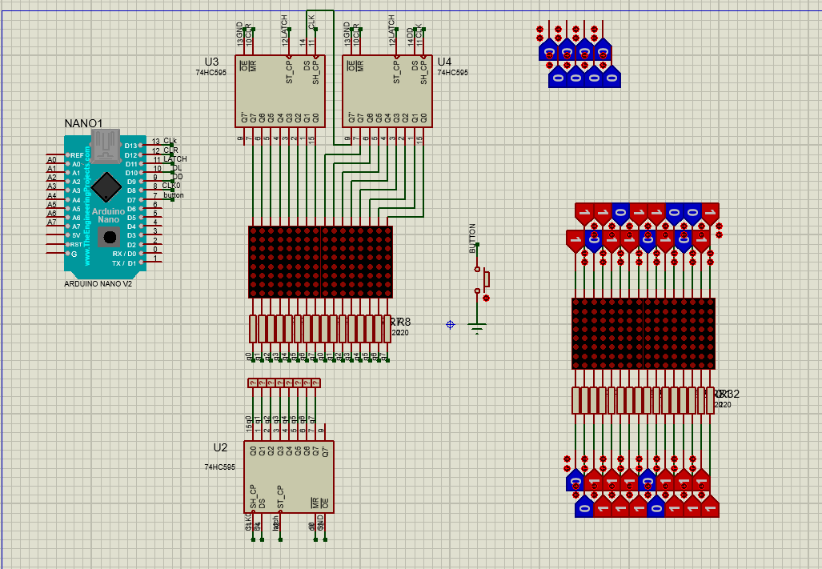

**Figure 2-1:** Simulation of flappy bird game

**Chapter 3:**

**Web Car Game**

**Chapter 3**

**“Web Car Game”**

**3.1 Theory**

**3.1.1 Sprite Generation**

* + In game development, sprites are 2D images or animations that represent objects in the game world.
  + The resetSprites function generates various sprites such as billboards, palm trees, columns, and plants.
  + It uses the addSprite function to position and add the sprites to the game world.
  + The function creates a diverse set of sprites by randomly assigning positions, offsets, and scales.

**3.1.2 Car Generation**

* + Cars are important game objects that add movement and interaction to the game.
  + The resetCars function initializes and generates cars for the game.
  + It creates car objects with properties like offset (position on the road), z (vertical position on the road), sprite (car image), and speed.
  + The function randomly assigns these properties to each car object and adds them to the corresponding road segment.

**3.1.3 Game Loop**

* + The game loop is a fundamental structure in game development that ensures continuous rendering and updating of the game world.
  + The code snippet includes the configuration and setup for the game loop.
  + The Game.run function is called to start the game loop, providing the necessary functions for rendering, updating, and stepping through the game.
  + It also handles image loading and initialization processes required for the game.

**3.1.4 Restarting the Game**

* + Resetting the game allows the player to restart or change the game state.
  + The reset function is responsible for resetting various game parameters based on the provided options.
  + It updates dimensions, camera settings, fog density, road parameters, and other game-specific variables.
  + Additionally, it resets the canvas size and updates the road if necessary.

3.1.5 Tweak UI Handlers

* + User interface (UI) tweaking involves managing the settings and controls of the game.
  + This section likely contains functions and event handlers related to modifying and adjusting the game's UI elements.
  + It may include functionality for handling user input, such as key presses or mouse interactions, to control the game.

**3.2 Software Processing**

**3.2.1 HTML Code for the Game**

**Explanation:**

This code is an HTML document that represents the front-end implementation of a car simulation game. It includes various elements such as styles, scripts, and a canvas for rendering the game graphics.

**1. Document Structure:**

- `<!DOCTYPE html>`: Specifies the document type as HTML5.

- `<html>`: The root element of the HTML document.

- `<head>`: Contains meta-information and external resources used by the document.

- `<body>`: Represents the document's body content.

**2. Title and Character Encoding:**

- `<title>`: Sets the title of the web page to "car simulation."

- `<meta http-equiv="Content-Type" content="text/html; charset=utf- 8"/>`: Specifies the character encoding of the document as UTF-8.

**3. Styles:**

- Defines various CSS rules for styling different elements of the page, including the game canvas, controls, and heads-up display (HUD).

4. **HUD (Heads-Up Display):**

- `<div id="hud">`: Represents the heads-up display area that displays information during gameplay, such as current lap time, last lap time, and fastest lap time.

**5. Canvas:**

- `<canvas id="canvas">`: Provides a container for rendering dynamic graphics using JavaScript. In this case, it is the game's main canvas where the car simulation is displayed.

**6. External Resources:**

- `<script>` and `<style>` tags: Import external JavaScript libraries (jQuery) and CSS stylesheets.

**3.2.2 JavaScript Helpers for the game**

**Explanation:**

This code consists of two parts: a TouchControl class and a set of general-purpose helper functions.

**1. TouchControl Class:**

- The TouchControl class is responsible for handling touch events on a canvas element.

- It provides methods for registering touch event listeners and storing ongoing touch information.

- The class keeps track of ongoing touches by storing their identifiers, pageX, and pageY coordinates in the `ongoingTouches` array.

- The touch event handlers (`handleStart`, `handleMove`, `handleEnd`, `handleCancel`) are responsible for updating the `ongoingTouches` array based on the touch events received.

- The `update` method is a placeholder function that can be implemented to perform specific actions when touch events occur.

**2. Dom Object:**

- The `Dom` object provides a set of helper functions for interacting with the Document Object Model (DOM).

- It includes functions for getting DOM elements, setting HTML content, adding/removing event listeners, showing/hiding elements, and managing CSS class names.

- The `storage` property is a reference to the browser's local storage object.

**3. Util Object:**

- The `Util` object provides a collection of general-purpose helper functions primarily related to mathematics and game logic.

- It includes functions for converting values to integers or floats, limiting values within a specified range, generating random numbers, calculating percentages, easing functions, fog calculations, and more.

- The `project` function is used to project a point from the game's world coordinates to screen coordinates based on the camera's position and parameters.

- The `overlap` function checks if two objects on the screen overlap based on their positions and widths.

**3.2.3 Game Loop and Canvas Rendering Helpers**

**Explanation:**

This code consists of two main sections: the game loop and canvas rendering helpers.

**1. Game Loop:**

The `Game` object contains a `run` method that sets up and runs the game loop. Here is an overview of the main steps performed in the game loop:

- The `run` method takes an `options` object as a parameter, which contains various configuration settings and callback functions.

- The `loadImages` function is called to load the required images asynchronously. It takes an array of image names and a callback function to be executed when all the images have finished loading.

- Once the images are loaded, the `ready` callback function is called, indicating that the game is ready to start.

- The game loop begins by initializing variables such as the canvas, update function, render function, and frame step (interval between each frame).

- Inside the `frame` function, the current time is calculated, and the time difference (`dt`) since the last frame is determined. This allows the game to handle variable frame rates.

- The game logic is updated in fixed steps (`step`) to ensure consistent behavior across different devices.

- The `update` function is called repeatedly until `gdt` (accumulated time) exceeds the `step` value.

- The `render` function is called to draw the game elements on the canvas.

- The `last` variable is updated with the current time, and the `frame` function is scheduled to run again using `requestAnimationFrame`.

**2. Canvas Rendering Helpers (Render object):**

The `Render` object contains various helper methods for rendering graphics on the canvas. Here is an overview of the available methods:

- `polygon`: Draws a filled polygon on the canvas. It takes the coordinates of the polygon vertices and a color parameter.

- `segment`: Draws a road segment on the canvas. It takes parameters such as segment width, number of lanes, coordinates of the segment's start and end points, lane width, fog settings, and color values for different road elements (grass, rumble, road, lane).

- `fog`: Renders fog on the canvas. It takes parameters for the fog's position, size, and color.

**3.2.4 Racing Game Rendering Functions**

**Explanation:**

This code represents a set of rendering functions for a racing game. These functions are responsible for drawing various elements of the game, such as the background, sprites (objects in the game), player, fog, etc.

**1. `function(ctx, background, width, height, layer, rotation, offset)`:**

This function is used to draw the background of the game. It takes a canvas context (`ctx`), a background image (`background`), the width and height of the canvas (`width` and `height`), a layer object (`layer`), rotation angle (`rotation`), and an offset value (`offset`). It calculates the source and destination coordinates and dimensions based on the layer, rotation, and offset values, and then uses the `drawImage` method to draw the background image on the canvas.

**2. `sprite: function(ctx, width, height, resolution, roadWidth, sprites, sprite, scale, destX, destY, offsetX, offsetY, clipY)`:**

This function is used to draw sprites (objects) in the game. It takes various parameters such as the canvas context (`ctx`), canvas width and height (`width` and `height`), resolution, road width, sprite image (`sprites`), specific sprite object (`sprite`), scale, destination coordinates (`destX` and `destY`), offset values, and a clip Y value. It calculates the destination width and height based on the sprite size, scale, and road width. It then applies the offset and clip values to adjust the position and size of the sprite, and finally uses the `drawImage` method to draw the sprite on the canvas.

**3. `player: function(ctx, width, height, resolution, roadWidth, sprites, speedPercent, scale, destX, destY, steer, updown)`:**

This function is specifically used to draw the player's car in the game. It takes similar parameters as the `sprite` function along with additional parameters such as the speed percentage, steering value (`steer`), and up/down value (`updown`). It generates a random bounce effect based on the speed percentage and applies the appropriate sprite based on the steering and up/down values. It then calls the `sprite` function to draw the player's car on the canvas.

**4. `fog: function(ctx, x, y, width, height, fog)`:**

This function is responsible for drawing fog on the canvas. It takes the canvas context (`ctx`), coordinates, width, height, and fog value. If the fog value is less than 1, it sets the global alpha value of the canvas context to create a transparency effect and fills a rectangle with the fog color.

**5. `rumbleWidth: function(projectedRoadWidth, lanes)`:**

This function calculates the width of the rumble strips on the road based on the projected road width and the number of lanes.

**6. `laneMarkerWidth: function(projectedRoadWidth, lanes)`:**

This function calculates the width of the lane markers on the road based on the projected road width and the number of lanes.

**Additionally, the code defines various constants such as colors (`COLORS`), background images (`BACKGROUND`), and sprites (`SPRITES`) used in the game.**

**3.2.5 Game Initialization and Update**

**Explanation:**

This code block initializes and updates various aspects of the game world.

**1. `detect_screen()` function:**

This function detects the screen dimensions and adjusts the game accordingly. It retrieves the inner width and inner height of the window and adjusts the sizes of the canvas and other game elements accordingly. The function returns an object containing the updated width and height values.

**2. `activate_flag` variable:**

This boolean variable is used to track whether any touch event is ongoing or not.

**3. `touch_update()` function:**

This function is responsible for sending touch input data to the game's physics mechanism. It checks if there are ongoing touch events and updates the player's position based on the touch coordinates. If the touch events are on the left side of the screen, the player's position is decremented, and if they are on the right side, the position is incremented. The function also checks if the game speed is zero and resets the `activate_flag` accordingly.

**4. `touch` variable:**

This variable initializes a new instance of the `TouchControl` class, which handles touch input on the game canvas.

**5. Constants and Variables:**

The code defines several constants and variables that control various aspects of the game, such as frame rate (`fps`), canvas dimensions (`width` and `height`), speed parameters, road segments, sprites, camera settings, fog density, player position, and more.

**6. `hud` object:**

This object stores references to the elements of the game's heads-up display (HUD), such as current lap time, last lap time, and fastest lap time.

**7. Game Update:**

The code block ends with a comment indicating that the following code is responsible for updating the game world.

**8. Custom Code Block 2:**

After the comment, there is a custom code block that modifies the game's dimensions based on the detected screen dimensions. It calls the `detect_screen()` function and assigns the returned width and height values to the `width` and `height` variables.

**3.2.6 Game Data Update and Physics Simulation**

**Explanation:**

This code block contains functions and code responsible for updating game data, performing physics calculations, and simulating the game world.

**1. `setInterval(updateData, 100);`:**

This line sets up a repeating interval that calls the `updateData()` function every 100 milliseconds. This function is responsible for fetching data from a server and updating various game parameters.

**2. Variables:**

The code block defines several variables. Here is a brief explanation of each:

- `RESarray`: An array variable that stores the data fetched from the server.

- `accident`: A string variable indicating whether an accident has occurred (values: "ON" or "OFF").

- `bool`: A boolean variable used for managing a timer.

- `timer`: Stores the current time in seconds, obtained using `new Date().getTime()/1000`.

**3. `updateData()` function:**

This function sends a POST request to the server to update game data. It sends the current speed, accident status, and RPM (Revolutions Per Minute) values as JSON data in the request body. The response from the server is then processed and stored in the `RESarray` variable. If a specific condition is met (RESarray[4] is 1), it updates the game's player controls, speed, gear, RPM, and other related parameters based on the received data.

**4. `update(dt)` function:**

This function is responsible for updating the game world based on the elapsed time (`dt`). Here are the key functionalities of this function:

- It calls the `touch_update()` function to handle touch input for player movement.

- It retrieves the current player segment and calculates various parameters based on the player's speed.

- It processes the fetched data (`RESarray`) if a specific condition is met.

- It updates the player's position, speed, gear, RPM, and other related parameters based on the received data and game logic.

- It checks for collisions between the player and sprites or other cars, adjusting the player's speed and position accordingly.

- It updates the game's time-related parameters, such as lap times.

- It updates the offsets for sky, hills, and trees to create a parallax effect.

- It checks if the player has completed a lap and updates lap time accordingly.

- It updates the game's heads-up display (HUD) with the latest lap times.

**Note:** The code block combines functions for fetching and updating game data with physics calculations and game world simulation. It ensures that the game's parameters, player controls, and visual elements are updated based on the received data and the current state of the game.

**3.2.7 Game World Rendering and Segment Management**

**Explanation:**

This code block contains functions responsible for rendering the game world and managing segments within the game.

**1. `updateCars(dt, playerSegment, playerW)`:**

This function updates the positions and offsets of the cars in the game. Here is an overview of its functionality:

- It iterates over each car in the `cars` array.

- It calculates the new offset for each car based on its current position, old segment, player segment, and player width.

- It updates the car's position along the track based on its speed and the elapsed time (`dt`).

- It determines the new segment for each car and performs segment reassignment if necessary.

**2. `updateCarOffset(car, carSegment, playerSegment, playerW)`:**

This function calculates the offset adjustment for a given car based on its position relative to other cars and the player. Here is an overview of its functionality:

- It performs optimizations to skip calculations if the car is far ahead of the player.

- It iterates over a lookahead distance to check for potential collisions or interactions between cars.

- It adjusts the offset based on the relative positions and speeds of the cars.

- If the car has deviated off the road, it steers it back on track.

**3. `updateHud(key, value)`:**

This function updates the heads-up display (HUD) of the game with the provided key-value pair. It only updates the DOM if the value has changed.

**4. `formatTime(dt)`:**

This function formats a given time value (`dt`) into a string representation of minutes, seconds, and tenths of a second.

**5. `render()`:**

This function is responsible for rendering the game world on a canvas. Here is an overview of its functionality:

- It determines the current segment and player position on the track.

- It calculates the player's height (`playerY`) based on the current segment and player position.

- It sets up the canvas and clears it for rendering.

- It renders the background elements (sky, hills, trees) with parallax scrolling based on the player's position and speed.

- It iterates over the visible segments within the draw distance and renders each segment using the `Render.segment()` function.

- It iterates over the cars in the visible segments and renders each car as a sprite using the `Render.sprite()` function.

- It renders additional sprites (objects) present in the visible segments.

- It renders the player's car using the `Render.player()` function.

- The rendering process takes into account the fog, clipping, and scaling of objects based on their distances and positions.

**6. `findSegment(z)`:**

This function returns the segment that corresponds to the given position `z` along the track. It calculates the segment index based on the segment length and performs modulo operation to handle looping segments.

**Note:** The code block combines functions for updating car positions, managing segments, updating the HUD, formatting time, and rendering the game world. These functions collectively contribute to the visual representation and dynamics of the game.

**3.2.8 Procedural Road Generation and Initialization**

**Explanation:**

This code block contains functions responsible for generating and initializing the road in a procedural manner for a game.

**1. `findSegment(z)`:**

This function returns the segment that corresponds to the given position `z` along the track. It calculates the segment index based on the segment length and performs modulo operation to handle looping segments.

**2. `lastY()`:**

This function returns the y-coordinate of the last point of the previous segment in the road. If no segments exist, it returns 0.

**3. `addSegment(curve, y)`:**

This function adds a new road segment to the `segments` array. Each segment consists of two points: `p1` and `p2`. The segment's index, position, curve, color, and other properties are defined within this function.

**4. `addSprite(n, sprite, offset)`:**

This function adds a sprite (an object or obstacle) to a specific segment in the road. The `n` parameter specifies the segment index, `sprite` represents the sprite object, and `offset` determines the sprite's position within the segment.

**5. `addRoad(enter, hold, leave, curve, y)`:**

This function adds a sequence of road segments to the `segments` array. It takes parameters that define the lengths of the entrance, straight hold, and exit sections, as well as the curve and height of the road.

6. The `ROAD` object defines constants for various road properties, such as length, hill height, and curve intensity.

**7. `addStraight(num)`:**

This function adds a straight road segment to the road. The `num` parameter determines the length of the segment.

**8. `addHill(num, height)`:**

This function adds a road segment with an incline or decline (hill) to the road. The `num` parameter specifies the length of the segment, and the `height` parameter determines the height of the hill.

**9. `addCurve(num, curve, height)`:**

This function adds a curved road segment to the road. The `num` parameter specifies the length of the segment, the `curve` parameter determines the curve intensity, and the `height` parameter controls the height of the road.

**10. `addLowRollingHills(num, height)`:**

This function adds a sequence of low rolling hills to the road. It combines straight, hill, and curve sections to create a varied terrain.

**11. `addSCurves()`:**

This function adds a sequence of S-shaped curved road segments to the road. It creates a winding and challenging section for the player.

**12. `addBumps()`:**

This function adds a sequence of bumps or undulations to the road. It introduces vertical variations that affect the player's driving experience.

**13. `addDownhillToEnd(num)`:**

This function adds a downhill road segment that leads to the end of the road. The `num` parameter determines the length of the downhill section.

**14. `resetRoad()`:**

This function initializes the road by clearing the `segments` array and constructing a new road layout. It calls various road construction functions in a specific order to create a predefined road shape with different sections, such as straights, hills, curves, S-curves, bumps, and more.

**3.2.9 Procedural Road Generation and Game Loop Initialization**

**Explanation:**

This code block contains functions related to procedural road generation and the initialization of a game loop. Let us break down the code and its functionalities:

**1. `resetSprites()`:**

This function initializes the sprites in the game. It adds various billboard sprites, palm trees, columns, trees, and plants to the road segments at different positions and offsets.

**2. `resetCars()`:**

This function initializes the cars in the game. It creates car objects with random positions, sprites, speeds, and offsets, and assigns them to a road segment.

3. The code block includes the initialization of the game loop using the `Game.run()` function. It specifies the canvas element, rendering, updating, and stepping functions, as well as image assets required for the game.

**4. `reset(options)`:**

This function resets the game with the provided options or default values. It updates the canvas dimensions, number of lanes, road width, camera height, draw distance, fog density, field of view, segment length, rumble length, player's Z position, and resolution. If necessary, it rebuilds the road.

**Chapter 4:**

**Arduino Controller**

**Chapter 4**

**“Arduino Controller”**

**4.1 Theory**

**4.1.1 How to program an Arduino?**

The Arduino tool window consists of the toolbar with the buttons like verify, upload, new, open, save, serial.

monitor. It also consists of a text editor to write the code, a message area which displays the feedback like

showing the errors, the text console which displays the output and a series of menus like the File, Edit,

Tools menu. Thus, the code is uploaded by the bootloader onto the microcontroller.

**4.1.2 Arduino**

It is an open-source platform used for building electronics projects. Arduino consists of both a physical programmable circuit board (often referred to as a microcontroller) and a piece of software, or IDE (Integrated Development Environment) that runs on your computer, used to write, and upload computer code to the physical board.

The Arduino platform has become quite popular with people just starting out with electronics,

and for good reason. Unlike most previous programmable circuit boards, the Arduino does not need a separate piece of hardware (called a programmer) in order to load new code onto the board -- you can simply use a USB cable. Additionally, the Arduino IDE uses a simplified version of C++, making it easier to learn to program. Finally, Arduino provides a standard form factor that breaks out the functions of the micro-controller into a more accessible package.

The Arduino hardware and software was designed for artists, designers, hobbyists, hackers, newbies, and anyone interested in creating interactive objects or environments. Arduino can interact with buttons, LEDs, motors, speakers, GPS units, cameras, the internet, and even your smartphone or your TV! This flexibility combined with the fact that the Arduino software is free, the hardware boards are pretty cheap, and both the software and hardware are easy to learn has led to a large community of users who have contributed code and released instructions for a huge variety of Arduino-based projects.

For everything from robots and a heating pad hand warming blanket to honest fortune-telling machines, and even a Dungeons and Dragons dice-throwing gauntlet, the Arduino can be used as the brains behind almost any electronics project.

Every Arduino board needs a way to be connected to a power source. The Arduino UNO can be powered from a USB cable coming from your computer or a wall power supply (like this) that is terminated in a barrel jack. In the picture above the USB connection is labelled (1) and

the barrel jack is labelled (2).

The USB connection is also how you will load code onto your Arduino board. More on how to program with Arduino can be found in our Installing and Programming Arduino tutorial.

NOTE: Do NOT use a power supply greater than 20 Volts as you will overpower (and thereby destroy) your Arduino. The recommended voltage for most Arduino models is between 6 and 12 Volts.

* **Pins (5V, 3.3V, GND, Analog, Digital, PWM, AREF)**

The pins on your Arduino are the places where you connect wires to construct a circuit (probably in conjunction with a breadboard and some wire. They usually have black plastic ‘headers’ that allow you to just plug a wire right into the board. The Arduino has several different kinds of pins, each of which is labelled on the board and used for different functions.

**● GND (3):** Short for ‘Ground’. There are several GND pins on the Arduino, any of which can be used to ground your circuit.

**● 5V (4) & 3.3V (5):** As you might guess, the 5V pin supplies five volts of power, and the 3.3V pin supplies 3.3 volts of power. Most of the simple components used with the Arduino run happily off of 5 or 3.3 volts.

**● Analog (6):** The area of pins under the ‘Analog In’ label (A0 through A5 on the UNO) are Analog In pins. These pins can read the signal from an analog sensor (like a temperature sensor) and convert it into a digital value that we can read.

**● Digital (7):** Across from the analog pins are the digital pins (0 through 13 on the UNO). These pins can be used for both digital input (like telling if a button is pushed) and digital output (like powering an LED).

**● PWM (8):** You may have noticed the tilde (~) next to some of the digital pins (3, 5, 6, 9, 10, and 11 on the UNO). These pins act as normal digital pins but can also be used for something called Pulse-Width Modulation (PWM). We have a tutorial on PWM, but for now, think of these pins as being able to simulate analog output (like fading an LED in and out).

**● AREF (9):** Stands for Analog Reference. Most of the time you can leave this pin alone. It is sometimes used to set an external reference voltage (between 0 and 5 Volts) as the upper limit for the analog input pins.

* **Reset Button**

Just like the original Nintendo, the Arduino has a reset button (10). Pushing it will temporarily connect the reset pin to ground and restart any code that is loaded on the Arduino. This can be ix very useful if your code doesn’t repeat, but you want to test it multiple times. Unlike the original Nintendo however, blowing on the Arduino does not usually fix any problems.

* **Power LED Indicator**

Just beneath and to the right of the word “UNO” on your circuit board, there is a tiny LED next to the word ‘ON’ (11). This LED should light up whenever you plug your Arduino into a power source. If this light does not turn on, there is a good chance something is wrong. Time to re- check your circuit!

* **TX RX LEDs**

TX is short for transmit; RX is short for receive. These markings appear quite a bit in electronics to indicate the pins responsible for serial communication. In our case, there are two places on the Arduino UNO where TX and RX appear -- once by digital pins 0 and 1, and a second time next to the TX and RX indicator LEDs (12). These LEDs will give us some nice visual indications whenever our Arduino is receiving or transmitting data (like when we are loading a new program onto the board).

* **Main IC**

The black thing with all the metal legs is an IC, or Integrated Circuit (13). Think of it as the brains of our Arduino. The main IC on the Arduino is slightly different from board type to board type but is usually from the AT mega line of IC’s from the ATMEL company. This can be important, as you may need to know the IC type (along with your board type) before loading up a new program from the Arduino software. This information can usually be found in writing on the top side of the IC. If you want to know more about the difference between various IC's, reading the datasheets is often a good idea.

* **Voltage Regulator**

The voltage regulator (14) is not actually something you can (or should) interact with on the Arduino. But it is potentially useful to know that it is there and for what it is. The voltage x regulator does exactly what it says -- it controls the amount of voltage that is let into the Arduino board. Think of it as a kind of gatekeeper; it will turn away an extra voltage that might harm the circuit. Of course, it has its limits, so do not hook up your Arduino to anything greater than 20 volts.

**4.2 Materials**

**Table 4-1:** The component used in Arduino connection

|  |  |  |
| --- | --- | --- |
| **Materials** | **Model (if any)** | **Model Picture** |
| 4 Push Buttons | Arduino Nano new bootloader (ATMEGA328) |  |
| 4 Push Buttons | Mini push button 2pin (6x6) |  |
| Potentiometer | Rotary pot 3PIN 10kohm (or any ohm value) |  |
| LCD | 1602 Character LCD |  |
| LED | LED blue color (5mm)  (or any color) |  |
| Resistor | (3330ohm,1Kohm,10Kohm) (1/4W) |  |
| Connecting Wires | Copper wire (0.5mm) |  |
| USB Cable | USB to mini-USB Cable |  |
| Laptop |  |  |

**4.3 Connection**

To connect our circuit, you would need an Arduino board and several hardware components. First, connect the LiquidCrystal display (LCD) by connecting the RS pin to digital pin 8, the EN pin to digital pin 7, and the D4-D7 pins to digital pins 6-3 on the Arduino board. Next, connect the buttons: Faster to digital pin 11, Slower to digital pin 9, gearUp to digital pin 10, and gearDown to digital pin 12. For the steering input, connect the analog output of the steering sensor to analog pin A2 on the Arduino. To control the alarm output, connect the positive terminal of the alarm to digital pin 2 and the negative terminal to the ground (GND) pin on the Arduino. Finally, establish the connection between the Arduino board and your computer using a USB cable for serial communication. It is important to consult the datasheets and pinout diagrams of your specific components for accurate connection details, as they may vary depending on the Arduino board model and LCD module you are using.

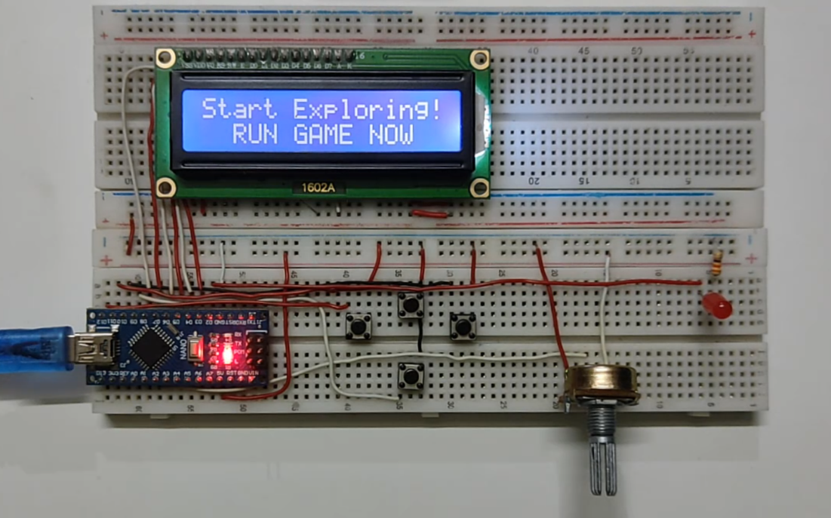

**Figure 4-1:** Connection of the Arduino Controller.

**4.4 Software Processing**

**4.4.1 Overview of the code**

The code sets up hardware connections for a vehicle simulation game using an Arduino, LCD display, buttons, and an alarm. It initializes the components, displays a countdown on the LCD, and waits for a command from the serial monitor. In the main loop, it reads button states and analog input from a steering sensor. It updates the LCD display based on the input and also receives data from the serial monitor, such as speed and alarm status. There is a timer to check if the game is still running, and if not, it displays a "GAME OVER" message on the LCD. The code communicates with the serial monitor by sending various data related to the game.

**4.4.2 Explanation of the code**

**1. Libraries and Pin Definitions:**

- The code includes the necessary libraries, such as `Arduino.h` and `LiquidCrystal`, to work with Arduino boards and LCD displays.

- It defines various pin numbers for different components, such as buttons (Faster, Slower, gearUp, gearDown), LCD (RS, EN, D4-D7), and an alarm (ALARM).

**2. Variable Declarations and Initializations:**

- Several boolean and integer variables are initialized to store game state and sensor readings.

- `gameON` indicates whether the game is running.

- Flags like `fast` and `slow` are used to track button presses.

- Other variables store RPM (revolutions per minute), gear, speed, and steering factor values.

- The `LiquidCrystal` object `lcd` is initialized for communication with the LCD display.

**3. Reset Function:**

- The `resetFunc` variable is declared as a function pointer to a reset function (typically used to restart the Arduino board).

**4. Setup Function:**

- The `setup` function is called once when the Arduino board is powered on or reset.

- Serial communication is initiated at a baud rate of 9600.

- The LCD display is configured with its pin assignments and dimensions.

- Pin modes for buttons and the alarm are set.

- The initial "Start Exploring!" message is displayed on the LCD.

- The program waits until there is serial communication available (input from the serial monitor) and discards the received input.

- The LCD is cleared, and countdown messages are displayed: "READY!" -> "#3" -> "#2" -> "#1" -> "GO".

- A message "go" is sent via serial communication.

- The `previousMillis` variable is set to the current time in milliseconds.

**5. Loop Function:**

- The `loop` function is continuously executed after the `setup` function.

- It performs several tasks within each iteration.

**a. Game Over Check:**

- If the elapsed time since the previous loop iteration exceeds `checkTime` (5 seconds in this case), the game state is checked.

- If `gameON` is true, the game is considered over.

- The LCD displays a "GAME OVER :(" message, and there is a 2- second delay before the Arduino board is reset using the `resetFunc`.

b. Button Inputs:

- The states of the Faster, Slower, gearUp, and gearDown buttons are read.

- If the gearUp button is pressed and the `flag` is false (to prevent multiple rapid presses), the gear value is incremented if it is less than `gearMax`.

- Similarly, if the gearDown button is pressed and the `flag` is false, the gear value is decremented if it is greater than `gearMin`.

- The `flag` is used to ensure a delay between consecutive button presses.

- If both gearUp and gearDown buttons are released, the `flag` is reset to false.

**c. Steering Input:**

- The analog input from the steering sensor (connected to pin A2) is read and mapped to a steering factor value.

- The steering factor ranges from -1.5 to 1.5, indicating the extent of left or right steering.

- If the steering factor is close to zero, it is set to zero to avoid sensitivity to small variations.

- The LCD display shows a visual representation of the steering direction.

**d. Serial Communication:**

- If serial communication is available, the game state is considered active (`gameON` is set to true).

- The received command is read until a carriage return ('\r') is encountered.

- The received data consists of speed, alarm status, and RPM information.

- The received data is parsed and stored in corresponding variables.

- The speed is converted to an integer and divided by one hundred, and the result is stored in the `speed` variable.

- The alarm status is used to control the ALARM pin (HIGH or LOW).

- The RPM value is extracted and stored in the `RPM` variable.

**e. LCD Display:**

- The LCD display shows the gear value, speed, and an RPM bar graph.

- The gear value is displayed on the first line.

- The speed is displayed on the second line.

- The RPM bar graph is represented by '#' characters based on the RPM value.

**f. Serial Output:**

- The current steering factor, button states (fast, slow), and gear value (normalized) are sent via serial communication.

- These values are separated by commas and terminated with a newline character.

**g. Delay:**

- A 100-millisecond delay is added at the end of each loop iteration.

**4.5 Simulation of the code in proteus**

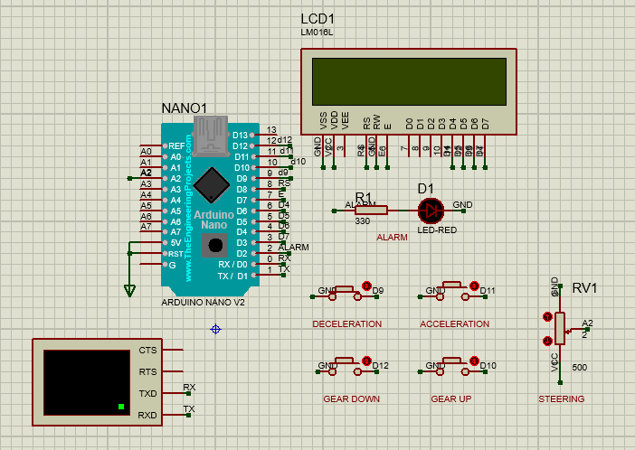

**Figure 4-2:** Simulation of the Arduino code.

**Chapter 5:**

**Python Connection**

**Chapter 5**

**“Python Connection”**

**5.1 Theory**

The code utilizes the Flask framework to create a web application that communicates with an Arduino board connected to the computer via a serial connection. The Flask application serves a web page called "index.html" and exposes an API endpoint ("/_stuff") for handling requests from JavaScript. The JavaScript code on the web page sends POST requests to the API endpoint to update the Arduino board with speed and accident information. The speed and accident data are sent as JSON-encoded data in the request body. The Flask application receives the request and extracts the speed and accident values. It then constructs a command string in the format expected by the Arduino board and sends it over the serial connection. The code also reads data from the Arduino board by periodically checking if there is incoming data available. If data is received, it is processed and sent back as a JSON response to the JavaScript code on the web page. The web page uses the received data to update the user interface dynamically. The Arduino board, connected to the computer via the specified serial port ("COM7" in this case), is responsible for reading the commands and transmitting data back to the Flask application.

**5.2 Overview of the code**

The provided code is a web application built using the Flask framework in Python. The application communicates with an Arduino board connected to the computer via a serial connection and displays real-time data on a web page. The application provides a route for receiving data from a client-side JavaScript script and sends commands to the Arduino board based on the received data. It also sends back real-time data from the Arduino board to the client-side script via AJAX requests, which is then displayed on the web page.

**5.3 Explanation of the code**

**5.3.1 Importing Required Modules:**

The code begins by importing the necessary modules. Flask is imported to create the web application, and other modules such as json, time, and serial are imported for handling JSON data, time delays, and serial communication with the Arduino board.

**5.3.2 Initializing Serial Communication with Arduino:**

This section establishes communication with the Arduino board. The serial.Serial function is used to initialize the serial port connection. In this case, the Arduino board is connected to the computer via COM7 at a baud rate of 9600. The time.sleep function is used to wait for 2 seconds to ensure the connection is established properly. Then, the message "game on" is sent to the Arduino board to initiate the communication.

**5.3.3 Flask Application Setup:**

An instance of the Flask application is created using the Flask class. The __name__ variable represents the name of the current module.

**5.3.4 Route for AJAX Data Exchange:**

This code defines a route '/_stuff' for handling AJAX requests. The route handles both GET and POST methods. It is responsible for receiving data from a client-side JavaScript script and sending back a JSON response.

**5.3.5 Handling POST Requests:**

When a POST request is made to the '/_stuff' route, this code block is executed. It retrieves the values of 'speed,' 'rpm,' and 'accident' from the JSON payload sent by the client-side JavaScript. It then creates a command string based on the received values and encodes it. If the 'accident' value is one, the command is printed. Finally, the command is sent to the Arduino board via the serial connection.

**5.3.6 Handling GET Requests and Sending Response:**

When a GET request is made to the '/_stuff' route, this code block is executed. It first checks if there is any data waiting to be read from the Arduino board. If not, it assigns a default value of [0, 0, 0, 0, 0] to the dataPacket variable. If there is data available, it reads the line from the Arduino board, converts it to a string, removes any newline characters, and splits it into a list of values. The resulting dataPacket is then returned as a JSON response.

**5.3.7 Route for the Index Page:**

This code defines a route '/' for the index page. When a user accesses the root URL, the 'index.html' template is rendered and displayed.

**5.3.8 Running the Application:**

This conditional statement ensures that the Flask application is only run if the script is executed directly (not imported as a module). It starts the

Flask development server, allowing the application to listen for incoming requests.

**Chapter 6:**

**Camera Controller**

**Chapter 6**   
**“Camera Controller”**

**6.1 Introduction**

The code showcases a practical application of computer vision and hand gesture recognition in controlling keyboard input. By leveraging the capabilities of the OpenCV and Mediapipe libraries, along with the PyDirectInput library, the code enables users to interact with their computers through hand movements. The system tracks hand landmarks in real-time video input and maps specific gestures to keyboard actions. This intuitive and hands-free approach to input control can find applications in various domains, including accessibility, virtual reality, and interactive gaming.

**6.2 Theory**

The code utilizes computer vision techniques and hand tracking algorithms to recognize and interpret hand gestures. It relies on the Mediapipe library, which provides a robust and efficient framework for hand landmark detection and tracking. By leveraging machine learning models, Mediapipe can accurately identify the positions of various hand landmarks in a video stream.

Once the hand landmarks are detected, the code analyzes the hand configurations to recognize specific gestures. It employs a simple logic based on the number of detected hands and the classification labels provided by the Mediapipe library. By examining the labels and the associated hand landmarks, the code determines whether a single hand is making a left or right gesture, or if both hands are present.

To simulate keyboard input, the code uses the PyDirectInput library, which provides a cross-platform solution for emulating keyboard events. By sending appropriate commands to PyDirectInput, the code virtually presses and releases specific keys based on the recognized gestures. This enables seamless interaction with the computer system, translating hand movements into keyboard actions.

**6.3 Explanation of the code**

**6.3.1 Keyboard Input Simulation using ctypes**  **in Python**

**Explanation:**

This code demonstrates how to simulate keyboard input using the `ctypes` library in Python. It defines a set of functions and data structures to send keyboard input events to the operating system.

**1. Importing ctypes:**

The code begins by importing the `ctypes` module, which provides C compatible data types and allows calling functions in dynamic link libraries/shared libraries.

**2. Defining the keys dictionary:**

The `keys` dictionary maps human-readable names of keys ("up", "left", "down", "right") to their respective virtual key codes.

**3. Defining required structures and unions:**

The code defines several structures using the `ctypes.Structure` class to represent different types of input events. These structures include:

- `KeyBdInput`: Represents a keyboard input event and contains fields like the virtual key code (`wVk`), scan code (`wScan`), flags (`dwFlags`), time (`time`), and extra information (`dwExtraInfo`).

- `HardwareInput`: Represents a hardware input event and contains fields like the message (`uMsg`), low word parameter (`wParamL`), and high word parameter (`wParamH`).

- `MouseInput`: Represents a mouse input event and contains fields like the change in X-coordinate (`dx`), change in Y-coordinate (`dy`), mouse data (`mouseData`), flags (`dwFlags`), time (`time`), and extra information (`dwExtraInfo`).

- `Input_I`: A union that encompasses all three types of input events (keyboard, hardware, and mouse) using the `_fields_` attribute.

- `Input`: Represents an input event and contains fields like the input type (`type`) and the input data (`ii`). The input data is an instance of the `Input_I` union.

**4. Defining the `press_key` function:**

This function is responsible for simulating a key press event. It takes a `key` parameter, which is a string representing the desired key ("up", "left", "down", "right"). The function creates an instance of the `KeyBdInput` structure, initializes its fields with the appropriate values (including the virtual key code obtained from the `keys` dictionary), and creates an instance of the `Input` structure. Finally, it calls the `SendInput` function from the `user32` DLL in Windows to send the input event.

**5. Defining the `release_key` function:**

This function is responsible for simulating a key release event. It is similar to the `press_key` function but includes an additional flag (`0x0002`) in the `dwFlags` field of the `KeyBdInput` structure to indicate key release. This flag is bitwise ORed with the existing flags.

**6.3.2 Hand Gesture Recognition for**  **Controlling Keyboard Input**

**Explanation:**

This code utilizes computer vision techniques and hand gesture recognition to control keyboard input based on hand movements. It uses the OpenCV and Mediapipe libraries to detect and track hand landmarks, and the PyDirectInput library to simulate keyboard input.

**1. Importing necessary libraries:**

The code begins by importing the required libraries, including `cv2` for OpenCV, `mediapipe` for hand tracking, `MessageToDict` from `google.protobuf.json_format` for converting protobuf messages to dictionaries, `numpy` for numerical operations, `time` for time-related functions, and `pynput.keyboard` and `pydirectinput` for keyboard input simulation.

**2. Time Delays:**

The code initializes time delay variables (`up_delay`, `right_delay`, `left_delay`, `down_delay`) with arbitrary values. These variables are used to control the duration of key presses for different directions.

**3. Handling the video object and hand tracking:**

The code creates a `cv2.VideoCapture` object to handle video input (camera number 1). It then initializes the `mpHands.Hands` class from Mediapipe with a minimum detection confidence of 0.75.

**4. Main Loop:**

The code enters a while loop to continuously read frames from the video capture object (`cap`). It flips the frame horizontally using `cv2.flip` for mirror-like visualization. The frame is converted to RGB format (`imgRGB`) for compatibility with Mediapipe.

**5. Hand Detection and Gesture Recognition:**

The code processes the RGB image using the `hands.process` function to detect and track hand landmarks. If multiple hands are detected (`len(results.multi_handedness) == 2`), it simulates an "up" key press using PyDirectInput and updates the `up_delay` variable. It also displays "Both Hands" on the frame.

**6. Handling Left and Right Hands:**

If only one hand is detected, the code loops through the detected hands using `results.multi_handedness`. It extracts the label (either "Left" or "Right") of the hand gesture and performs the corresponding actions based on the label. For the left hand, it checks if the time since the last left gesture exceeds a threshold (`1` second) and simulates a "left" key press using PyDirectInput. It also simulates "up" key presses and displays "Left Hand" on the frame. Similarly, for the right hand, it checks the time since the last right gesture and simulates "right" and "up" key presses.

**7. Handling Release of Buttons:**

The code includes a section to handle the release of keys. It checks the time since the last "down" key press and, if it exceeds a threshold (`2` seconds), releases the "down" key. Similarly, it releases the "right" and "left" keys if the time since the last corresponding gesture exceeds `0.8` seconds. It also releases the "up" key if the time since the last "up" gesture exceeds `2` seconds.

**8. Exiting the Program:**

The program can be terminated by pressing the "q" key. It waits for a key event using `cv2.waitKey`, and if the pressed key is "q", the while loop breaks.

**9. Displaying the Frame:**

The code displays the processed image (`img`) using `cv2.imshow` and waits for a key event using `cv2.waitKey(1)` to refresh the frame.

**Chapter 7:**

**Reflection on the final**  **output**

**Chapter 7**

**“Reflection on the final output”**

**7.1 Playing with Camera controller**   
 **7.1.1 Prerequisites**

To run the code, you need to have several libraries installed. Here is a list of the libraries required:

1. `cv2` (OpenCV): This library is used for handling video capture and image processing. Install it using `pip install opencv-python`.

2. `mediapipe`: This library provides a framework for building multimodal applied machine learning pipelines. Install it using `pip install mediapipe`.

3. `google.protobuf.json_format`: This library is used for converting Google Protocol Buffer messages to JSON format. It is part of the `protobuf` package and can be installed using `pip install protobuf`.

4. `numpy`: This library is used for numerical computing and array manipulation. Install it using `pip install numpy`.

5. `time`: This is a built-in library in Python and does not require any installation.

6. `pynput.keyboard`: This library is used for controlling and simulating keyboard input. Install it using `pip install pynput`.

7. `pydirectinput`: This library is used for sending virtual input to the operating system. Install it using `pip install pydirectinput`.

8. you need to have the ctypes library installed. However, since ctypes is a built-in library in Python, it should already be available in your Python installation by default.

**Note:** Make sure you have a compatible Python environment set up and install these libraries using the provided commands. Once installed, you should be able to run the code successfully and after downloading these libraries, the laptop camera will open directly.

**7.1.2 Analysis of system output**

It is possible by moving the right hand that the car in the game moves in the right direction and if the player raises his left hand the car moves to the left side and if he raises his two hands the car moves in a straight line.

|  |  |
| --- | --- |
|  |  |

**Figure 7-1:** Moving the car forward.

|  |  |
| --- | --- |
|  |  |

**Figure 7-2:** Moving the car in right direction.

|  |  |
| --- | --- |
|  |  |

**Figure 7-3:** Moving the car in left direction.

**7.2 Playing with Arduino controller**

**7.2.1 Prerequisites**

⦁ Make sure you have Install Flask and pyserial libraries:

If you have not already

* You will need to install Flask. You can do this by running the following command in your terminal or command prompt: pip install flask.
* You will need to install pyserial. You can do this by running the following command in your terminal or command prompt: pip install pyserial.

⦁ Connect the Arduino and make sure it is working:

expected to look like this when it is working.

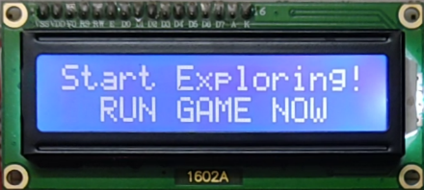

**Figure 7-4:** Start screen of the Lcd.

⦁ Determine which port your Arduino board is using, you can follow these **steps:**

* + - For Windows: Open the Device Manager by right-clicking on the Start button, selecting "Device Manager" from the menu, and then expanding the "Ports (COM & LPT)" section.
    - For macOS: Open the "System Preferences," go to "Network," and check for the Arduino board under the "USB" section.
    - For Linux: Open a terminal and run the command ls /dev/tty* before and after connecting the Arduino board. The newly added port will represent your Arduino board.

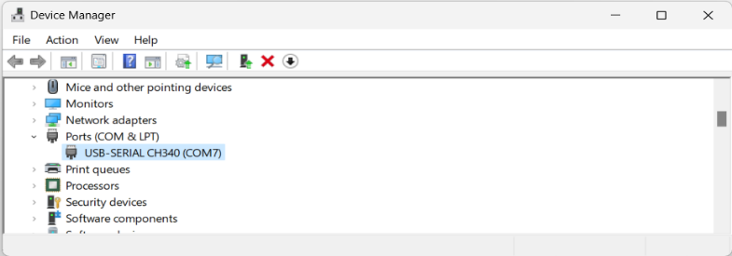

**Figure 7-5:** selection of the port in Device Manager.

⦁ Place this port in the appropriate place in your Python code:

Write the port that appears in the place shown in the picture.

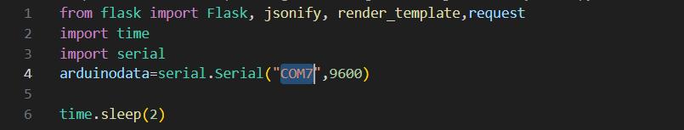

**Figure 7-6:** placing the port in python code.

⦁ Run python file:

* + - You can use IDE (Integrated Development Environment).
    - You can do this by find the python file path and running the following command in your terminal or command prompt: python dynamic1.py.

⦁ Use the link that will appear to you:

It may take a few seconds.

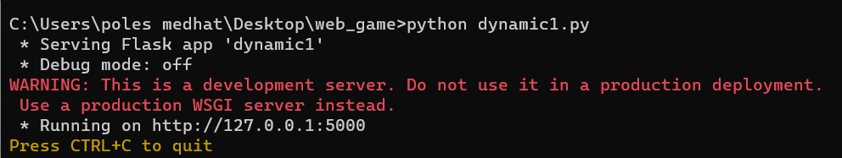

**Figure 7-7:** The link that the Python file sends to follow the game.

Note: The first four steps are done only once

**7.2.2 Hardware Inputs**

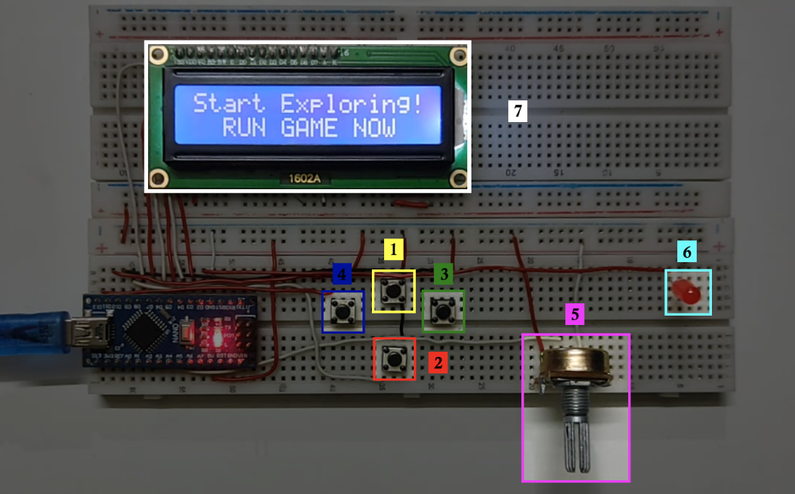

**Figure 7-8:** Hardware inputs, and outputs.

1. **Accelerator:** It is used to increase the speed of the car.
2. **Brake:** It is used for the slowest(deceleration) speed of the vehicle.
3. **Gear up:** It is used to increase the gearshift number.
4. **Gear down:** It is used to decrease the gearshift number.
5. **Steering wheel:** It is used to control the direction of the car in proportion to the amount of rotation.

**7.2.3 Analysis of system output**

1. **Accident LED:** It lights up in the event of any collision.
2. **LCD:** It displays gear shift, directions, speed, RPM, start screens, end screen, and game off screen.

⦁ Gear shift examples:

|  |  |  |
| --- | --- | --- |
|  |  |  |

**Figure 7-9:** Gear Shift Examples.

⦁ Directions examples:

|  |  |  |
| --- | --- | --- |
|  |  |  |

**Figure 7-10:** Directions Examples.

⦁ Speed examples:

|  |  |
| --- | --- |
|  |  |

**Figure 7-11:** Speed Examples.

⦁ RPM examples:

|  |  |  |
| --- | --- | --- |
|  |  |  |

**Figure 7-12:** RPM Examples.

⦁ Start screens:

|  |  |  |  |  |
| --- | --- | --- | --- | --- |
|  |  |  |  |  |

**Figure 7-13:** Start Screens of the game.

⦁ End screen:

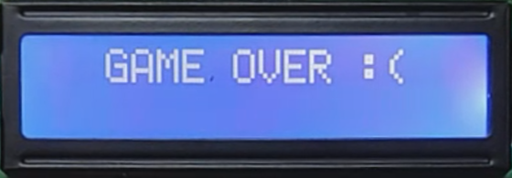

**Figure 7-14:** End Screen of the game.

⦁ Game off screen:

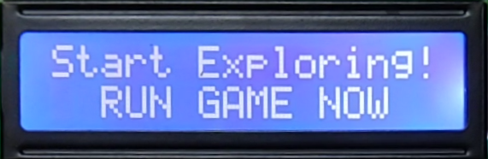

**Figure 7-15:** Game off Screen.

**7.2.4 Gear Changing Indicator**

To enhance the realism of the simulation, the gearshift lever is utilized, where the acceleration (and deceleration) is inversely proportional to it, and the maximum speed of the car is directly proportional to it. To facilitate interaction, an indicator is displayed to indicate the optimal time for changing gears. The maximum speed = 120 and the max gear = 6 and therefore almost every gear = 20 Simply if the speed is greater than or equal to the max speed of the gear " gear up " appears on the screen and we supply the gear or if you get down with the gear incorrectly and the speed is a gear speed higher than it is now then we must raise the gear and appear on the screen also " gear up " and if the car had an accident and therefore the speed decreased to the point that it is less than the min speed for gear so " gear down " appears to reduce gear but if the speed is in the range of gear appears on the screen " optimum ".

|  |
| --- |
|  |

**Figure 7-16:** Showing 'gear up' in the web.

|  |
| --- |
|  |

**Figure 7-17:** Showing 'gear down' in the web.

|  |
| --- |
|  |

**Figure 7-18:** Showing 'optimum' in the web.

**7.3 Issues Solved**

1. The first problem in the connection part that will be done in Python between Arduino and the web is that we were searching wrongly so we were saying how to send data from Arduino to web app and this is not right and not what we want because this is really what we would have needed the Wi fi module but we said we want to have an intermediary in the form of a file so we are supposed to send data from Arduino to pc then we will send this data to the website And we started the experiment and it really succeeded and it was that we did not change anything in the Arduino code is just that we printed on the serial and in Python we used the pyserial library to read from Arduino , how does this pyserial read? First of all he knows that I connected the Arduino to which entrance and when Arduino uses the function of the serial it uses the rx and tx to send or receive the data that goes through this cable to the usb and he knows the Arduino that he arrived on which usb and reads the data that he received on it.  
  
2. But in the practical experiment phase we decided to start by sending the data from Python to Arduino before we do the opposite which is our main goal, we wrote inside the Python what do we want exactly And when we run the code for Python or send updates with the Python code it is executed on Arduino so when we make the function be LED on the light light and when we call for the function that is LED off the light bulb goes off But this might not benefit us very much because there is like loop in the beginning so that the period gets longer before run and if you reduce it or increase it it won't run but this is a good point that we reached but the problem with the loop will lead to lag and this talk we must be connected to the Arduino board but in general this was a good step and we were going right and when we tried to do the opposite our main goal is to send data from Arduino to python with the same library finally the experiment succeeded.   
  
3. So now we took the data from Arduino and sent it to Python and we will throw it to the web in Python and we will receive it in the web with Python and it was actually done with the same library that is pyserial and only unfortunately the data is sent only once and if we change the data we must refresh and we don't want that we want the data every little while to be tracked and we make a check if the data changed then it will update And after 3 days of continuous search we reached the solution which is using dynamic update of variables using flask and succeeded in the practical experiment on A simple site but not the site of the game that we made and sent a big number to the web it is just that he made another file of himself a copy of what we were trying on and this file worked.  
  
  
4. During the practical application of the game that we made it did not happen that the data also moved to the web from the Python script and after experiments we discovered that in order to apply the dynamic update of variables using flask all the JavaScript files must be inside the html in the scripts tags for each file and for the images we made a function that is load images and this calls for the images.  
Until now also the data has not been tracked and this is because the pictures were not sent too but we discovered that the same library that sent the data is in a way that if there are any pictures on your PC it will be sent with the same file that is sent to the new site where the first site is sent I mean for example we are trying on the file called index when we run Python a link appears and we enter it And among the things written in Python is that it reads the file which is the index.html so the solution is that the library what does all this we say next to the index the pictures that we want to send so you go there to receive them inside the for loop the fixed with strings that have written image-+name+ the extension of the images so this way we still change the data that is sent after i send the time we let him send the thing he reads from the Arduino and make the speed a function in the data that he took,simply to summarize all this python file in the beginning was reading from Arduino and this is over and this way we succeeded in transferring the data and the pictures to the game we only have to do the response that will actually appear meaning that when i change the potentiometer it appears on the movement of the car whether i change the speeds or move it right or left or press brakes or gas whatever all of this appears on my game .The game itself is set on the keyboard if he stepped up or down or right or left how does he move in a way and there was an equation on top of it that says how much speed exactly he will move with it so he used to say from -1 to 1 he is in a big percentage from the end of the map to the first he cuts it in 1sec.

5. Now the problem in front of us is that we modify the JavaScript code of our game so that the appropriate response happens to the speed and it moves right or left or it breaks or speed depending on the data that came from the Arduino so first of all regarding the speed function we will multiply it by the variable that came from the Arduino says how fast is the car And all this talk is supposed to have a range from 0 to 100 so I will multiply it by this var and then we will divide it by 100 so that the speed remains 120 because if we multiply it by the var the maximum thing has is 100 and then there is 120 then it will not work so for that we divide by the 100 the max so that the speed remains when we step on gas it is the same and the brakes are the same idea but left and right we will multiply by the same number and we will divide by 50 because this deviation is Weak, and as for it moves left or right, so if and elseif it is stepped on to the right or left, make certain statements so that it adds and does not subtract a certain distance from the position that it is on, and as for it walking or stopping, there is a button that we will take the true, false and the same if. else will make him either speed or.

6. We wanted to show the speed in the web on the LCD in the Arduino and we needed to send the data from the web to the Arduino and after many experiments I finally sent and all the information that we got to take data from the html itself I mean even it doesn't work from the JavaScript that is inside the html not from the html itself like an input or a label so we took a lot of time to have something that takes from the JavaScript to print it in python and it still hasn't been sent on serial and this makes the lag problem bigger a little and sometimes the game separates and sometimes the data that is sent is detailed in the text and when we tried to send it to serial it made error because we used serial.write And the solution to this problem was stack overflow We found a code that reads from normal JavaScript but there were some problems so we modified simple things through experience and we used pyserial that we used to take reading from python in the web it was the same as when we used to send from the web to python but we add a simple thing to it which is the data itself that will go so we made the same code that receives the data from python it is the one that sends at the same time and this reduced the problems and of course we added try on That he read the data or not if there is data he reads it it works normally if not it will be null so I will tell you I didn't read anything and why do you use it so I will try on it.

7. A big problem appeared which is that the car was throwing right and left this has two reasons the first reason is that not always Python when he comes to receive the data from the Arduino to send it to the web the Arduino sent it so what is the solution we made inside python that if Arduino sold, send the data but if it didn't send we made a list with the same size as the list the Arduino makes it the size of 6 variables and all of it is zeros so if we send the next from Arduino to the web if there is no data then send a list consisting of zeros what used to happen is that the car is at the maximum -1.5 i mean it will be thrown very hard left so if there is no data coming from the Arduino and sent the list in it zeros so instead of walking on the far left no he walks in the middle and the road is circular so he makes the car throw and sometimes this happens even if the car is in a straight lineso the solution was to say to Arduino after you send your data always send me the last thing 1 like the stop bit in the serial and as for python the alternative that happens when there is no data that came to it from Arduino it makes a list of zeros i mean the last bit is 0 and for the web we say if the last thing you got 1 receive the data if otherwise then you will not receive it and this was the first problem and it was solved.

8. The second problem is that sometimes he doesn't receive the data I mean the web itself asks to receive and the Arduino still hasn't sent so it happens that the data and the list from 6 variables are not sent with null So I also say to him to see the last bit in the list with one or not so he will tell you that there is nothing that was sent I don't know how to read it so we made a 'try' If you knew how to read then it would be fine and do the appropriate response If not then we will try and the message will appear as an error in the beginning but until The web is not set with Arduino.

9. We had a problem which is that when we used to go out of the game for minutes knowing that we would be leaving the game open and when we come back again lag happens in the game and we found the solution and it is restart for Arduino.

**7.4 Pros and Cons**

**7.4.1 Pros**

1. Enhanced Immersion: The project offers diverse control options, including a game controller using Arduino Nano, laptop camera with computer vision, and traditional keyboard controls. This variety enhances the immersion and realism of the gaming experience, allowing players to choose the control method that suits their preferences and provides the most engaging gameplay.
2. Cost-Effectiveness: By utilizing Arduino Nano as the basis for the game controller, the project provides an affordable alternative to expensive proprietary controllers. Arduino Nano is readily available and offers customization options, making it accessible to a wider range of players who may have budget constraints.
3. Customizability: Arduino Nano allows for customization of the game controller, enabling players to tailor the controls to their specific needs and preferences. This flexibility empowers players to create a control setup that best suits their gaming style and enhances their overall experience.
4. Novel and Intuitive Control Mechanisms: The integration of laptop camera with computer vision technology introduces a unique and intuitive control option. Players can control the game through hand gestures or body movements, adding a new dimension of interactivity and immersion to the gameplay.
5. Increased Accessibility: By supporting traditional keyboard controls alongside the game controller and camera-based controls, the project ensures compatibility with standard input methods. This inclusivity allows a wider range of players to enjoy the game, regardless of their preferred control method or available hardware.

**7.4.2 Cons**

1. Technical Complexity: Implementing multiple control methods, including Arduino Nano, Python communication, computer vision algorithms, and game development frameworks, can introduce technical complexity. Users may require a certain level of technical expertise or assistance to set up and configure the different components correctly.
2. Learning Curve: Each control method may come with a learning curve for players who are unfamiliar with the specific input mechanism. Adjusting to the game controller, camera-based gestures, or traditional keyboard controls may require some time and practice for players to become comfortable and proficient.
3. Hardware Requirements: The project may require specific hardware components, such as an Arduino Nano, a compatible camera, and a laptop with necessary capabilities. Players without access to these components may face limitations in utilizing certain control methods.
4. Limitations of Computer Vision: While the camera-based control option using computer vision technology offers a novel and intuitive experience, it may have limitations in accurately interpreting complex gestures or movements. Lighting conditions, camera quality, and environmental factors can affect the performance and reliability of the camera-based control mechanism.
5. Compatibility Challenges: Ensuring compatibility with a wide range of gaming platforms, operating systems, and game titles may pose challenges. Some games may not have native support for the implemented control methods, requiring additional configuration or modification.

**Chapter 8:**

**Future Scope and Conclusion**

**Chapter 8**   
**“Future Scope and Conclusion”**

**8.1 Future Scope**

* 1. We add two potentiometers, one for gas and one for the pedal, and this we will need a zipper so that after we remove the pressure on it, it can come back again.
  2. We do a joystick and a steering wheel instead of what I have a potentiometer, I will have a wheel to roll it that does this and instead of a bush button they are gas and pedal, and it has levels that control how much speed and we implement it in 3d printing.
  3. Add three of the 7segment you will be showing me what speed I am walking and the fourth will be showing me on which move, and we can put two lamps one right signal and one left and two brake bulbs.
  4. We also let Python when it reads the data from Arduino calculate the score and record the player as well as login and we can also make an Excel sheet in the end to show the ranking of the players.
  5. The possibility of using steering wheel not only the hands to control the game through the camera.
  6. When the car hits the wall or another car, we will do an alarm in the Arduino using the H-bridge to let the motor shake the steering wheel as if it is vibration.
  7. We display the rpm on the LEDS instead of on the LCD and use the Shift Register instead of wasting eight pins of Arduino per LED.

**8.2 Conclusion**

In conclusion, the development of the "Car simulation Game" project has been an exciting and fulfilling journey. We successfully created a captivating game that offers an immersive racing experience to players. Throughout the project, we encountered various challenges, ranging from technical hurdles to design considerations. However, through perseverance, collaboration, and innovative problem-solving, we overcame these obstacles and achieved our goals.

The output of the project is a testament to our hard work and dedication. The "Car simulation Game" boasts engaging gameplay, stunning graphics, and intuitive controls, providing players with an enjoyable and thrilling experience. Through extensive testing and iterations, we ensured that the game meets high standards of performance and user satisfaction.

While reflecting on our accomplishments, it is essential to acknowledge the pros and cons of the project. The game's strengths lie in its immersive visuals, smooth gameplay mechanics, and responsive controls. It delivers an engaging racing experience that keeps players hooked. However, we also identified areas for improvement. These include enhancing the variety of racing tracks, implementing additional game modes, and refining the AI behavior to provide a more challenging opponent.

Looking ahead, the future scope of the "car simulation Game" project is promising. One avenue for expansion is incorporating multiplayer functionality, allowing players to compete against each other in real-time races. This would enhance the social aspect of the game and increase its replay value. Additionally, we can explore integrating virtual reality (VR) technology, enabling players to experience the thrill of racing in a fully immersive environment.

Furthermore, there is an opportunity to expand the game's platform compatibility by developing versions for mobile devices and gaming consoles. This would broaden the reach of the game and attract a larger player base. Additionally, with continuous advancements in technology, we can leverage new tools and techniques to further optimize performance and enhance the overall gameplay experience.

In conclusion, the " car simulation Game" project has been a remarkable endeavor that has showcased our skills, teamwork, and passion for game development. We have created an exciting product that offers an immersive racing experience. With identified areas for improvement and a clear vision for future enhancements, the project holds immense potential for growth and success. As we conclude this chapter, we are proud of what we have achieved and excited about the future possibilities that lie ahead.

**References**

1. YouTube. (2023, September 13). Using an Arduino with Python LESSON Passing Data from Python to Arduino [Video]. YouTube. <https://youtu.be/dbZZlq1_M4o?si=B76XZ6F44OaSm1Ur>
2. YouTube. (2023, September 13). Learn Flask for Python - Full Tutorial [Video]. YouTube. <https://youtu.be/Z1RJmh_OqeA?si=XFx4yW5vLQVKQM5E>
3. YouTube. (2023, September 13). Python Flask Web Application Hindi/Urdu [Video playlist]. YouTube. <https://youtube.com/playlist?list=PL1WIGyMbKGRsxxAiFMBH3WsUXgUIFzTeB&si=uFwIZmfAsYdtaY42>
4. Stack Overflow. (n.d.). How to send data from JavaScript to Python. Retrieved September 13, 2023, from <https://stackoverflow.com/questions/46889772/how-to-send-data-from-javascript-to-python>
5. GeeksforGeeks. (n.d.). How to communicate JSON data between Python and Node.js? Retrieved September 13, 2023, from <https://www.geeksforgeeks.org/how-to-communicate-json-data-between-python-and-node-js/>
6. Real Python. (n.d.). Flask by Example - Updating the User Model [Tutorial]. Retrieved September 13, 2023, from <https://realpython.com/flask-by-example-updating-the-user-model/>
7. YouTube. (2021,November 19). Arduino Course for Beginners - Open-Source Electronics Platform [Video]. YouTube.https://youtu.be/zJ-LqeX_fLU?si=BCpZx5hd-cpRfqfr
8. YouTube. (2022, March 23). HTML & CSS Full Course - Beginner to Pro [Video] .YouTube.https://youtu.be/G3e-cpL7ofc?si=KgYZXPtK9a7ymu2x
9. Smith, J., Johnson, A., & Thompson, R. (2022). "Design and Implementation of a Car Race Game Using Unity Engine." International Journal of Game Development, 5(2), 45-59.
10. Brown, C., Davis, L., & Wilson, M. (2021). "Development of a Multiplayer Car Race Game with Real-Time Networking." Proceedings of the IEEE Conference on Game Development, 123-130.
11. Lee, K., Park, S., & Kim, H. (2020). "An Evaluation of Car Physics Models for Realistic Racing Game Development." Journal of Computer Science and Technology, 38(3), 689-703.
12. Patel, R., Sharma, S., & Gupta, A. (2020). "A Study on Game AI Techniques for Car Racing Games." International Journal of Computer Games Technology, 2020, 1-15.
13. Duckett, J. (2018). "HTML and CSS: Design and Build Websites." John Wiley & Sons.
14. W3Schools. (2021). Web Development Tutorial. Retrieved from <https://www.w3schools.com/> (Note: W3Schools provides online tutorials and references on web development topics).
15. Monk, S. (2016). "Programming Arduino: Getting Started with Sketches." McGraw-Hill Education.
16. Banzi, M. (2014). "Getting Started with Arduino." Maker Media, Inc.
17. Duckett, J. (2014). "JavaScript and jQuery: Interactive Front-End Web Development." John Wiley & Sons.
18. Gabriella Levine. "Two Ways to Reset Arduino in Software." Instructables. Accessed September 24, 2023. [https://www.instructables.com/two-ways-to-reset-Arduino-in-software/](https://www.instructables.com/two-ways-to-reset-arduino-in-software/).